(Approx. 836 words)

Software Review: OpenOffice
By Ronnie Ugulano, Fresno PC Users Group, California, newsletter editor
http://fresnocomputerusers.org
ronnieuggie(at)mail.com

Obtained from APCUG with the author's permission for publication by APCUG member groups.

I didn't have time to monkey around. It had to work out of the box. I got an email from the FPCUG Board saying that they would like to be able to offer the newsletter in PDF for easy printing, pretty please. To be honest, I knew this was coming, but it now was time to implement. OK, what are my options? What do I already have that I can use to do this? I could copy and layout the text and graphics in Microsoft Word, but I'd still need to convert it to PDF. I've been working with Linux lately, and it has Scribus available, a lovely Desktop Publishing program, but I already have everything for the newsletter set up on my Windows computer, and wasn't ready to flit back and forth with that, yet.

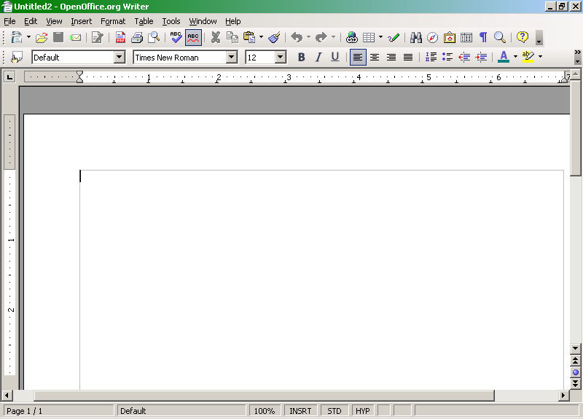

Oh, yeah, I remembered! OpenOffice, the available-free office suite program has a PDF converter built into it's word processing program, and there's a Windows version! The big questions are: "Can I use what I know about MS Word enough to make it work as fast as I need it to?" I hope so. So, I rummage through my collection of downloaded, saved utilities and programs, and find it right where I left it. Double click, install and open the program.

Well, the tools appear familiar. I just may get this to work, after all.

I want the printed newsletter to look as much like the html version as much as possible, so the first order of business is to convert some of the CSS “graphics” to jpgs or gifs, which I do using Paint Shop Pro 9. The next job is placement. How do I insert a graphic file? . .ah, there it is, similar to MS Word, under Insert > Picture > From File. OK, place them where I want them, size them to proper dimensions, and it's good.
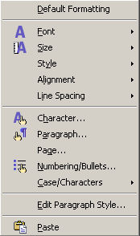

Next, every newsletter has certain features that appear in every issue, such as The Fine Print, the Sanity Savers and the list of board members/officers. All that is specially formatted with tables. How will I migrate that? . .I try clicking, dragging, and pasting thinking “I'll just have to fix the formatting later”, and bam! Much to my surprise, the formatting holds up. Not only that, but the specialized shading does too. I mentally throw a little confetti in celebration. What about rather standardized, simple keyboard commands like Ctrl + Z (undo), Ctrl + C (copy), Ctrl + V (paste), Ctrl + B (bold) and Ctrl + I (italics)? No surprises there, things work as usual.
Then of course, you never know what you'll get when you right click on something, right? Hmm. Right click gives you the tools menu seen at right, and double clicking on the graphic itself (In OpenOffice Writer - in the html version, you'll get the full sized graphic) once it's placed, allows you to set how much space you want around the graphic, among other things.
The newsletter has colored headers, and font color is in almost exactly the same place as MS Word, so finding that is a no-brainer. There are about 100 colors to choose from there, and I choose the one closest to the color I use on the html version of the newsletter.
Next, was page numbers. The html version doesn't need them, but the printed edition will. In MS Word, choosing to add page numbers will almost automatically place those numbers in the margin as you specify. With Writer, you choose to create the footer first, by going Format > Page > Click Footer Tab > OK, click in the created footer and then click Insert > Fields > Page Number. Doing this automatically places the page number consecutively on each page.
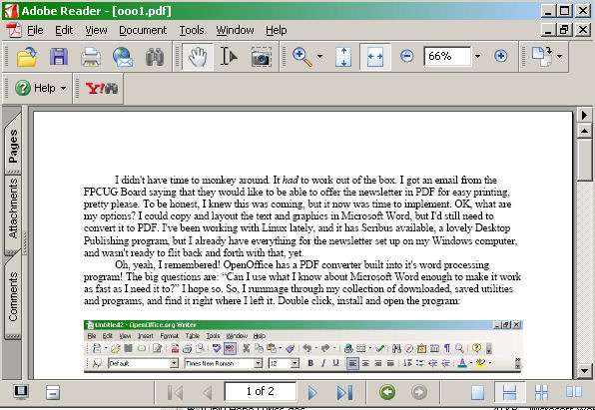There are plenty of other word processing tools, including columns, mail merge, macros and so forth, and they are outside what I need for this first time around, but they are there, and findable, when I need them.

The last tool I'll need, and the whole purpose of this exercise, is the PDF conversion tool. For this, I initially created this document in a separate file so I can test drive this option before I use it on the newsletter itself. It's time to click that button now, and just like magic, a PDF is created!
You know, I've never progressed past my copy of Office 97. I've just never bothered to upgrade – probably because I'm too cheap. Every new computer I've built, I've just reloaded the old Office 97 as part of my setup ritual. It may be that on my next computer, I'll be loading OpenOffice.org instead.

This article has been provided to APCUG by the author solely for publication by APCUG member groups. All other uses require the permission of the author (see e-mail address above).

